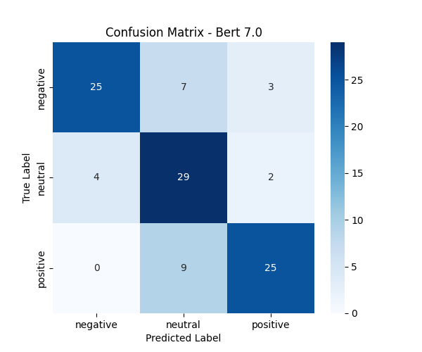

positive

True Label

neutral

negative

0

4

25

Confusion Matrix - Bert 7.0

-25

7

3

- 20

29

- 15

29

2

- 10

25

-5

- 0

negative

neutral Predicted Label

positive